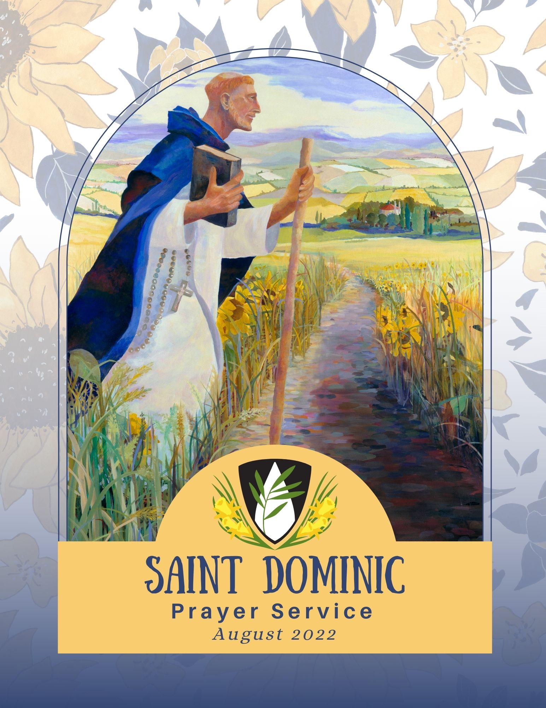
This prayer service has opportunities for many readers.
It includes readings from Scripture, from histories, and books written by Dominicans.

LEADER OF PRAYER:
In the beginning
the Spirit hovered over the “Seignadou” “making all things new”.

Alone
Dominique looked out
over the vast expanse of creation.

From his side, wounded by compassion, the Holy Preaching of Prouilhe was formed for his joy
and so that his Order
be mysteriously fruitful.

The first nuns gathered
and there was a time of foundation,
growth, and communion before the friars came who were later dispersed throughout the world.

(Quote from the 800th Anniversary booklet: Sainte-Marie de Prouilhe
By Sr. Barbara Beaumont O.P., Fr. Elie Pascal Epinoux O.P., Sr. Marie de Jesus O.P.)

OPENING SONG:
In Dominic we claim to be Through all the world one family. O Praise God! Laudare!
A living heritage we share

Family of Dominic (3 verses)

Of study, common life, and prayer. Laudare! Alleluia!
Benedicere! Alleluia! Praedicare!

To east and west, to south and north, O sisters, brothers, now go forth!
Be a blessing! Benedicere! Throughout the universe release God’s reign of justice, love, and peace! Laudare! Alleluia!
Benedicere! Alleluia! Praedicare!

How beautiful upon the earth
The feet of those who bring God’s word! Preach the Gospel! Praedicare!
The path we walk is holy ground; The word we speak a holy sound! Laudare! Alleluia!
Benedicere! Alleluia! Praedicare!

Text: Mary Fran Fleischaker, OP

PRAYER:
God of Mercy,

All

In your eternal Wisdom, you called your servant, Dominic to set off on a journey of faith as itinerant pilgrim and preacher of grace. With your Word of gentle Truth in his heart and on his lips, Dominic invited the first sisters and brothers to join him in a life of contemplative obedience in the service of the holy preaching, 800 years ago.

READER:
In that same spirit, Father Thomas Wilson OP, in February 1822, at the local St. Rose parish in Kentucky, publicly invited young women to consider forming a community of Dominican Sisters, not cloistered as in Europe, but leading an active life and pronouncing simple vows. Nine women responded to the appeal and on Easter Sunday April 7, 1822,

four women were received formally into the Order of Preachers and received the habit as Dominican Sisters. In August of the same year, six more candidates received the habit of the Order. They became the first foundation of Dominican Sisters in the USA, and the first active congregation of women in the Order of Preachers.

PRAYER:
As we commemorate this 200th year Jubilee, we ask you to breathe the Spirit of the risen Christ once again into our hearts and minds. Re-create us, so that we might faithfully

All

and joyfully proclaim the gospel of peace, through the same Christ, our Lord. Amen.

Adapted, from Sainte-Marie de Prouilhe

PSALM 148
Praise God! Give praise from the heavens, Give praise in the heights.
Give praise, all angels;
Give praise, all hosts of heaven.

Give praise, sun and moon; Give praise, all shining stars. Give praise, highest heavens And waters above the heavens.

Let them praise the name of our God, The Creator who called them forth, Who set each in place
Forever and ever.

Let them praise the name of our God, The Creator who called them forth, Who set each in place
Forever and ever.

Dominican Praise

Praise the Lord from the Earth, All creatures of the deeps,
Fire and hail, snow and mist, Blowing winds that obey God’s word.

Mountains and hills, Fruit trees and cedars, Creatures wild and tame,
You that crawl and you with wings,

Rulers of the Earth and every nation, Princes and judges,
Young men and maidens, Elders and youth together,

Let all praise the name of our God, This name alone is exalted,/
Covering heaven and earth in splendor, God gives strength to the people
And glory to the faithful,/ Israel and all who are near. Alleluia.

Glory to You, Source of all being, Eternal Word and Holy Spirit, Who dwells in our midst
Both now and forever. Amen.

READER:

Ephesians 3:17-21

May Christ dwell in your hearts through faith, as you are being rooted and grounded in love, so that you may be fully able to grasp, with all the holy ones, what is the breadth and length, the height and depth, and know the love of Christ that is beyond all knowledge, that you may be filled with all the fullness of God.

Glory to God whose power is able to accomplish in us infinitely more than we can ask or imagine! Glory to God in the church and in Christ Jesus from generation to generation forever.

Dominican Praise

MOMENT OF SILENCE RESPONSE:
May we always be attentive to the Lord. May our lives be proclamations of the Word. May we celebrate Life with great joy.

READER:
What Dominic sought and obtained from the Pope was not the approval of a Dominican Rule but confirmation of the outrageous novelty of forming an order of preachers. The way in which the new Order was canonically inserted into the church was a way that was transparent to the demands of the gospel and which left them free to work out for themselves how they could best fulfill their function as preachers, recognizing that this involves at least a certain degree of adaptation to the specific milieu in which they might be working.
Simon Tugwell, OP

SILENT REFLECTION, PREACHING OR SHARING RESPONSE:
May we always be attentive to the Lord. May our lives be proclamations of the Word. May we celebrate Life with great joy.

All

All

READER:

Philippians 1:3-6

I thank my God every time I remember you in prayer. I constantly pray for all of you with joy because you have shared in the preaching of the Gospel from the first day until now. I have no doubt that the One who began this good work in you will complete it on the day of Christ Jesus.

Dominican Praise

A PREACHER’S PSALM

Alternating Sides

“In the beginning was the Word; the Word was with God and the Word was God.” (John 1)

As Christians and Dominicans of all stripes, we together are invited to preach the living Word, Who dwells among us.

As Dominican Sisters and Associates, confirmed in our faith, we preach within the ordinary round of life.

We preach Good News under the burden of Integrity, fueled by the grace of shared Wisdom.

We preach with our conversations, not only when those communications are about Divinity but also as we share the fruits of our learning and experience.

We preach the causes of Justice and Peace to form the reign of God, even when we are imperfect.

We preach through poetry and the arts and bring awareness of our precious and fragile Earth, our only home, even when we are misunderstood or ridiculed.

We preach kindness in silence and work, in looks and in actions—we are preachers of the Word made flesh, Who dwells in us and among us.

Written by a Lay Dominican, adapted

DOMINICAN MAGNIFICAT

Sung

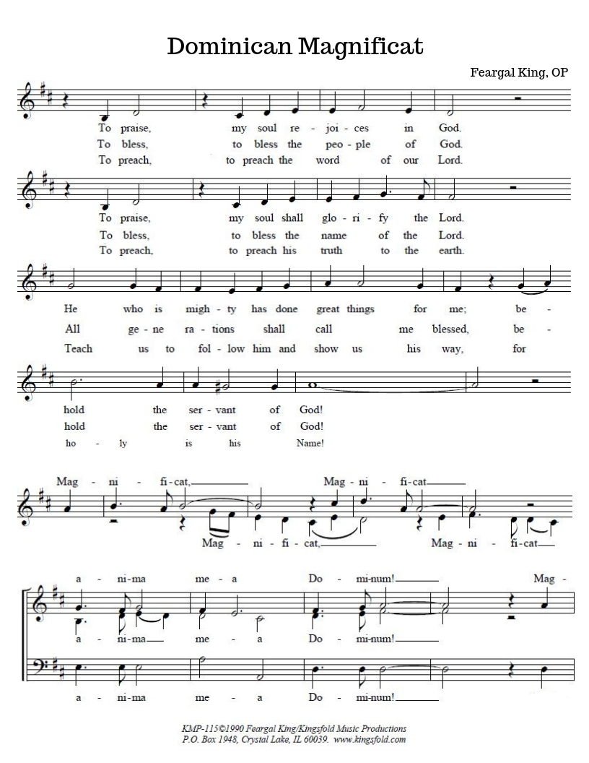

MP3:
https://drive.google.com/file/d/1HdosMbxsCJvxrGUEH8IsNI djUBSKEZHU/view?usp=sharing

SPONTANEOUS INTERCESSIONS
Optional

CLOSING PRAYER:
Gracious and loving God, we praise and thank you for our Dominican Family. We ask that your continued blessing be evident in all that we are and do as we strive together to carry out our mission of holy preaching. We ask this in the
All

company of Mary Magdalene, Dominic, Catherine and all our brother and sister saints, through Christ Jesus our Lord.
Amen.

DOMINICAN BLESSING
May God Creator bless us, May God Redeemer heal us,
And may God the Holy Spirit fill us with light, And may God the Holy Trinity fill with peace.

Sung

Music by Amy McFrederick, OP

MP3:
https://drive.google.com/file/d/1DYF0O0apW4aXifZ0hBiI- dWhwKExSrkc/view?usp=sharing

SIGN OF PEACE

CLOSING SONG:
200th Anniversary Song

Garden of Peace

Music by Teresa Tedder

MP3:
https://drive.google.com/file/d/1s0j5A9nWjsQ_RDvrEgc885w Y1S3EFuZF/view?usp=sharing

